**Part I: Hybrid Images**

For the hybrid image part, two images were chosen—one of a lion and one of a man. The result of this hybrid image was the best of the three that had been created. The function that was created for outputting the hybrid images applied a Gaussian filter to the gray scaled image of choice, resulting in a low passed image. T This was followed by a Laplacian filter to the other image of choice by first applying a Gaussian filter to the gray scaled image and then subtracting that from the original gray scaled image, thus creating a high passed image. The high and low passed images were then combined. The resulting image shown in figure 3 shows the lion as the high passed image and the man as the low passed image. One of the ways used to test which sigma value to use for the Gaussian filtered image was to do a for loop that would increment up one each time while doing the same for the Laplacian filter. This provided various images and from those the best was chosen. When doing an analysis of

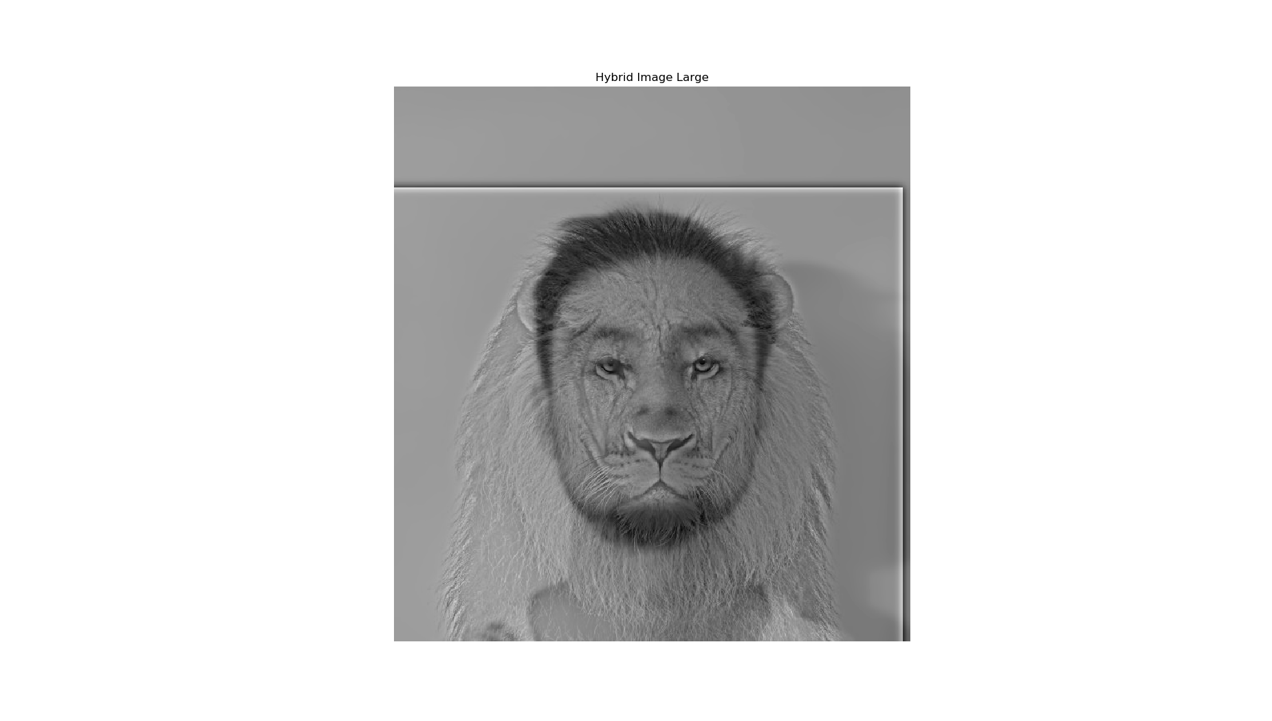

*figure 3*

*figure 2*

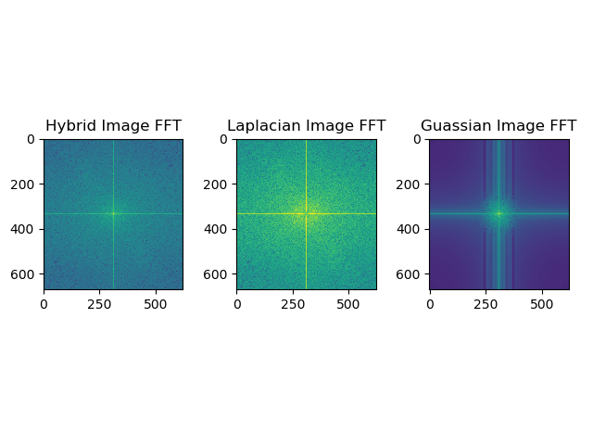

*figure 1*

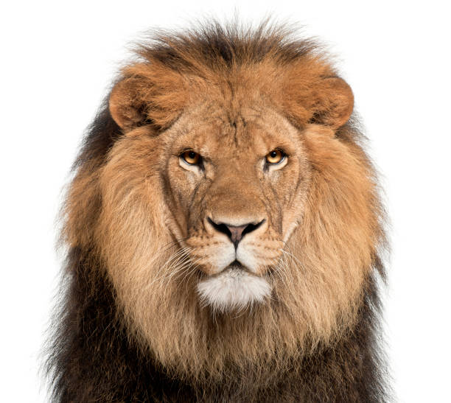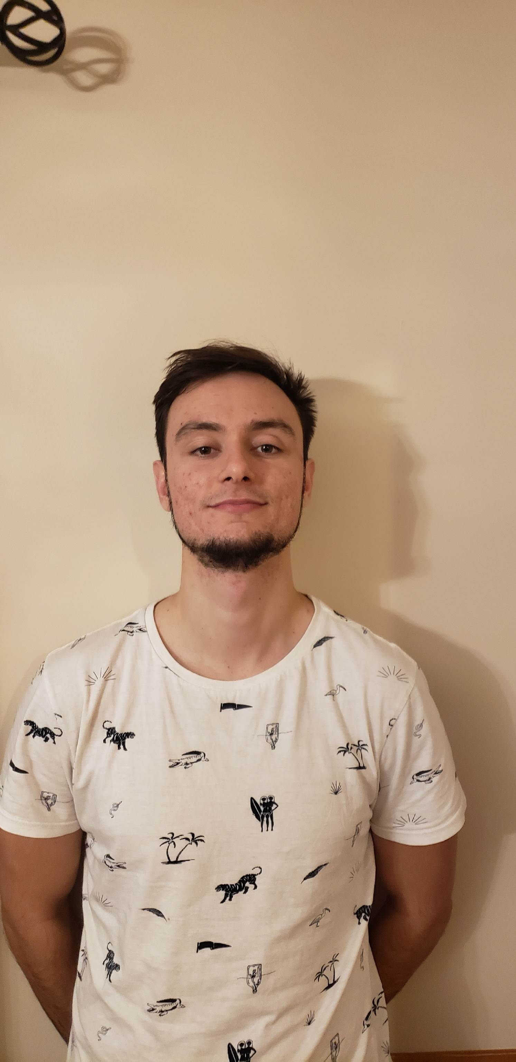

the FFT plots (figure 2) it was found that the Gaussian filtered image had filtered out almost all the high frequency while the Laplacian filtered out all the low frequencies which resulted in a nice plot for the hybrid image.

The same process was done for two other hybrid images. The images shown in figure 4 were applied to the same function as described before. When combined, the resulting image was not as successful as the first. One of the potential reasons for this occurrence was the orientation of the girl in the original photo was at a sideways angle than the original cat, resulting in the aligned images being more rotated. The other problem was when the low pass filter was applied, there was still some noise in the high frequencies areas shown in the FFT plot of the Gaussian image in figure 5. The

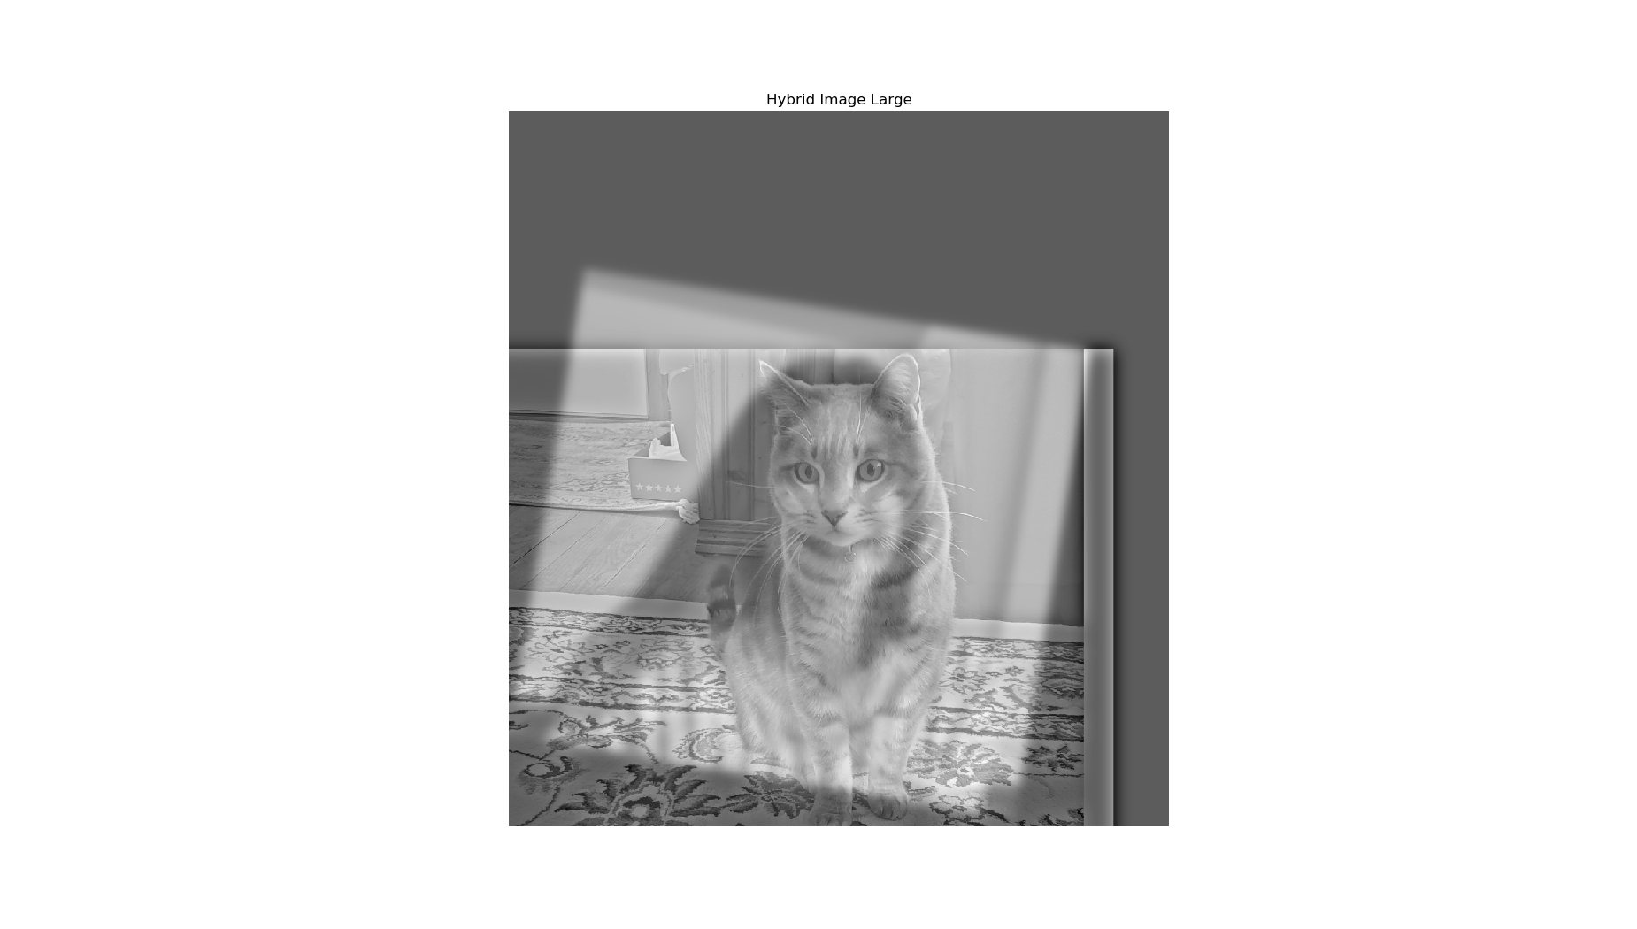

*figure 6*

*figure 5*

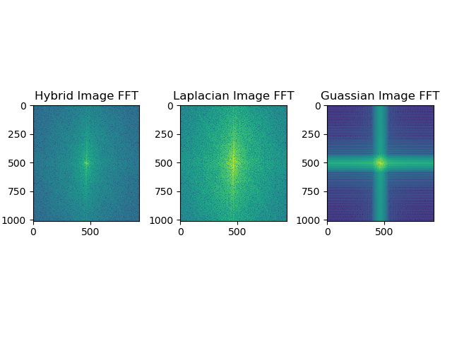

*figure 4*

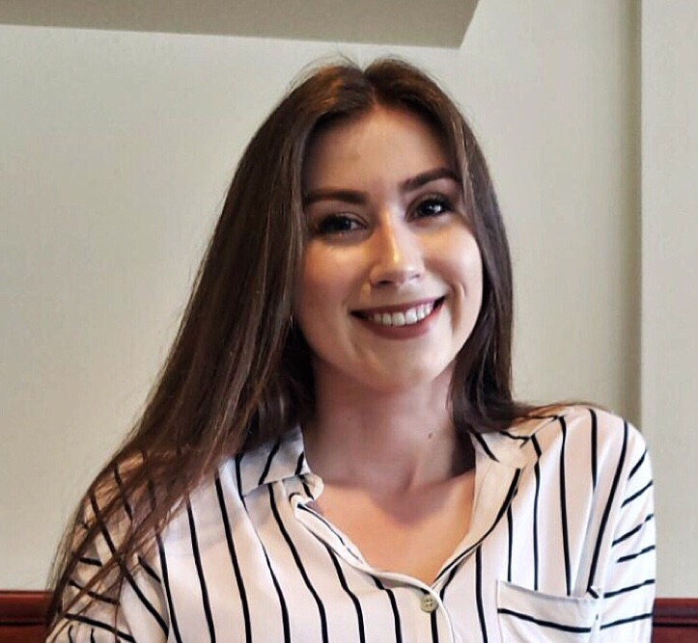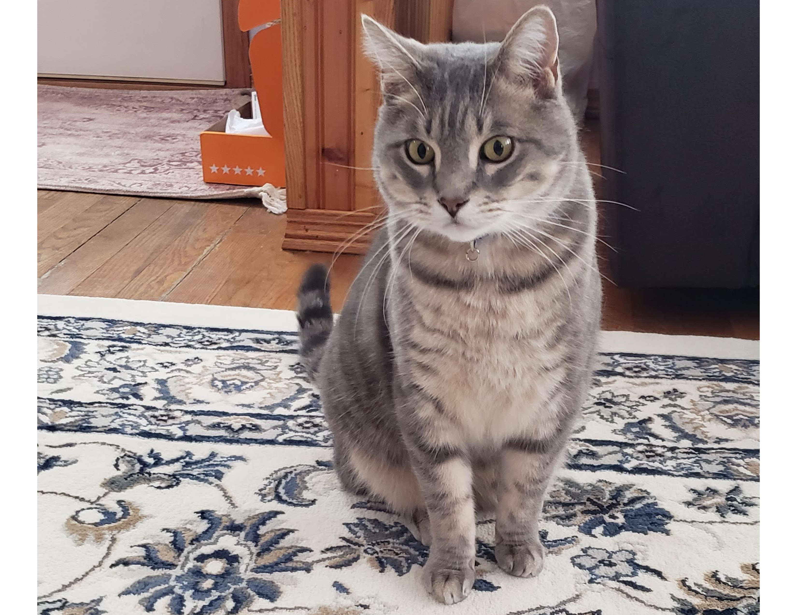

product image shown in figure 6 shows the cat as the high passed image and the girl as the low passed image combined together.

The last image that was created involved using two pictures of brothers show in figure 7.

*figure 9*

*figure 7*

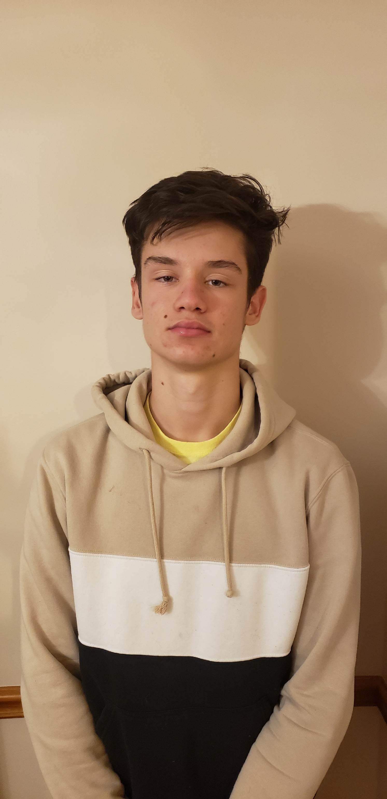

It becomes challenging to diferentiate hybrid image when looking at it from close versus farther away because the faces in each picture prior to combination are already similar. This took a little bit more trial and error to get the correct sigma value for each image. The FFT plot shown in figure 8 came out suprisingly well, similar to that of the lion image.

*figure 8*

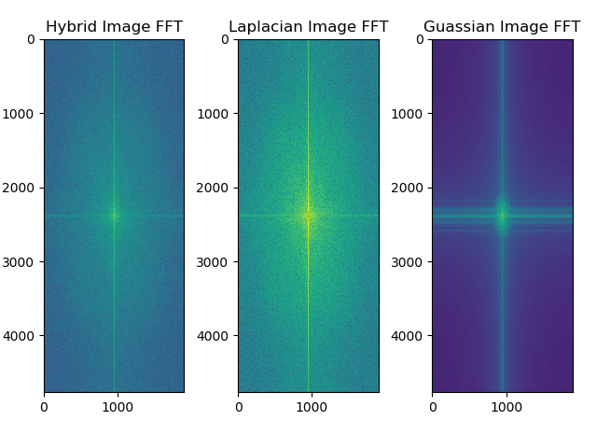

One of the problems while creating the final product was the allignment of the hair on both heads. Another issue is of the beard which can be seen from both far away and close up but was only in one of the original images. The resulting image is shown in figure 9.

*figure 10*

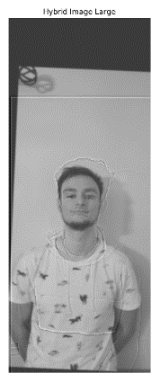

**Part II: Image Enhancement**

**Contrast Enhancement**

For this part, a photo of a group of friends is seen in figure 10 which was taken in lower light that is difficult to see and also a little blurry.

Histogram equalization was used to edit the image by first converting the image to the HSV color space. Then, the built-in histogram equlization function in opencv2 was used on the value channel. Finally, the image was converted back to the RGB domain to output it. The orginal image had more dark values, as evidenced by the histogram of figure 11. The equalized image had a better distribution of values, which is shown in figure 12.

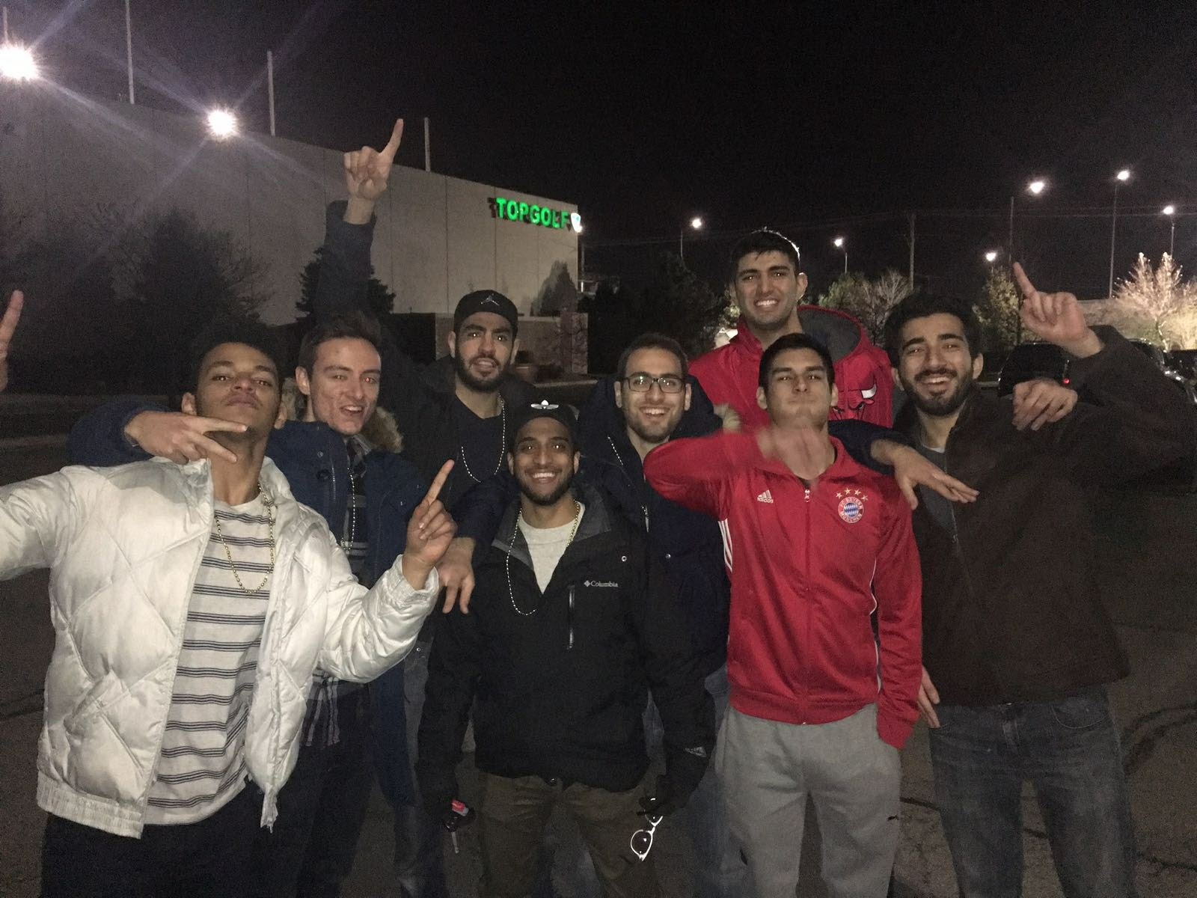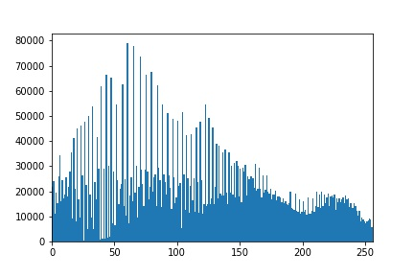

*figure 12*

*figure 11*

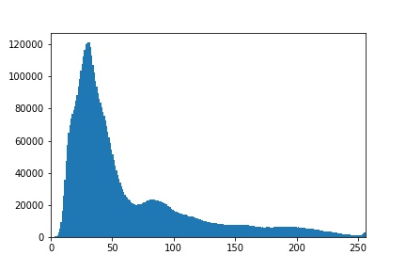

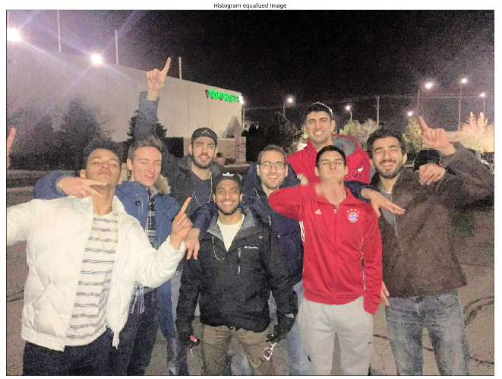This was used over gama correction to get a better distribution of values instead of changing every value by a multiplier. The final image is shown below in figure 13.

*figure 14*

*figure 13*

**Color enhancement**

Color enhancment was done to an image by converting it again to the HSV color space. The saturatuion is associated with how bright an image is. To get more vivid colors, many saturation values were experimented to get the correct lighting to an image. Ultimetly it was chosen to linearly add 2o to the saturation of the image and cap it off at 255 since the values are mapped from 0-255. The difference can be seen in figure 14 showing how an image taken on a cloudy day can be transformed to look brighter and have more vivid colors. The V in HSV was not used beacuase it would higher the intesisty of the image which was not asked for.

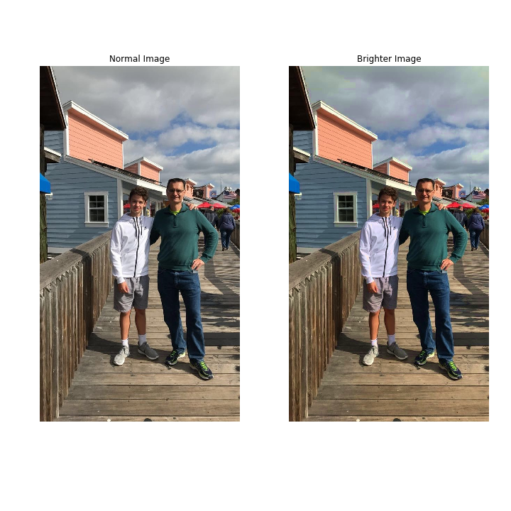

**Part III: Bells & Whistles**

**Color Shift**

The image shown in figure 15 is of a chicken with lots of colors. The goal was to be able to first create an image that was more red. The image was first converted into the LAB color space and through trial and error adding and subtracting values to the A and B channels. The output is shown in figure 16, with an added value of 10 to the A channel and 3 to the B channel, outputing a more red image.

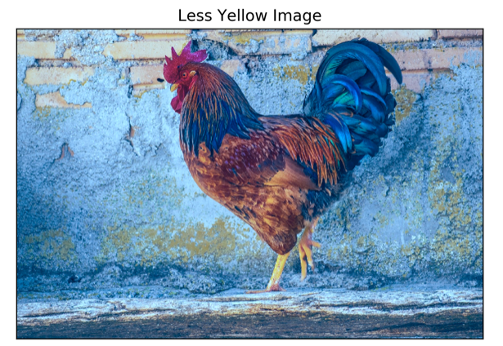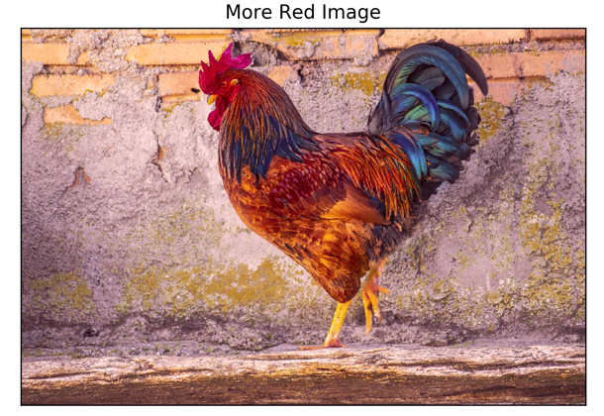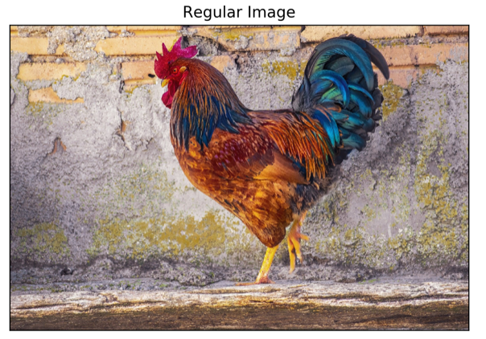The second part was to create an image that was less yellow. Again, trial and error was implemented in the LAB color space and 30 was subtracted from the B channel and 10 was subtracted from the A channel, outputing a less yellow and more blue image shown in figure 17.

*figure 15*

*figure 17*

*figure 17*

**Hybrid images in Color**

Going back to the hybrid images, it was determined that using color in both the high and low frequency component was the best option. The high frequency image is harder to see up close because of the low frequncy parts still visible in the image. The final image is shown in figure 18. Figure 3 is the same hybrid image but done in gray scale.

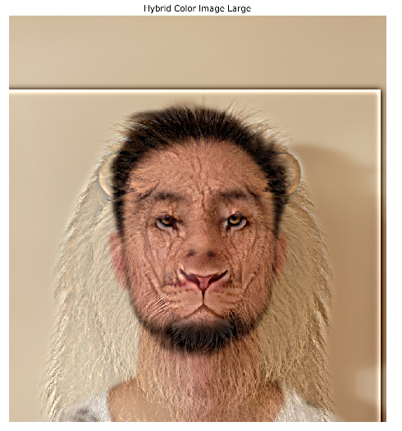

*figure 18*

**Gaussian and Laplacian pyramids**

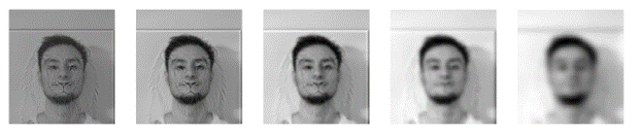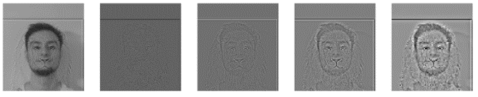The Laplacian and Gaussianpyramids are shown in figure 19 for the hybrid image shown in figure 3. To create a Gaussian pyramid, a low pass filter is applied to the image and then the image is subsampled. The process is then repeated for the subsampled image each time. The Laplacian is calculated by taking the pre-filtered image and subtracting it from the Gaussian image each time down the pyramid.

*figure 19*

**Sources**

Lion image:

<https://www.pngitem.com/so/lion-face/>

Chicken image:

<https://pixabay.com/photos/gallo-feathers-colorful-animals-4752996/>